

**FLY AWAY PLUS**

**DETAIL DESIGN DOCUMENT**

**Class Design**

**Project Code: FAP**

**Document Code: FAP_Class Design_v1.2_EN**

**Record of Change**

*A-Added M-Modified D-Deleted

|  |  |  |  |  |
| --- | --- | --- | --- | --- |
| Date | Item | A, M, D* | Change Description | Version |
| 2015/08/14 | Add new | A |  | V1.0 |
| 2015/08/20 | Package Diagram  Package Description | M |  | V1.1 |
| 2015/08/23 | Wish List | A |  | V1.2 |

Table of Contents

1. Introduction 5

1.1. Purpose 5

1.2. Definitions, Acronyms and Abbreviations 5

2. Package 6

2.1. Package Diagram 6

2.2. Package Description 7

2.2.1. Model 7

2.2.2. View 9

2.2.3. Controller 9

3. Function 12

3.1. Search 12

3.1.1. Class Diagram 12

3.1.2. Sequence Diagram 13

3.2. Help Center 14

3.2.1. Class Diagram 14

3.2.2. Sequence Diagram 15

3.3. Suggest 15

3.3.1. Class Diagram 15

3.3.2. Sequence Diagram 16

3.4. Personal Page 17

3.4.1. Class diagram 17

3.4.2. Sequence Diagram 17

3.5. Post Management 25

3.5.1. Class Diagram 25

3.5.2. Sequence Diagram 26

3.6. Share Management 28

3.6.1. Class Diagram 28

3.6.2. Sequence Diagram 28

3.7. Comment Management 29

3.7.1. Class Diagram 29

3.7.2. Sequence Diagram 30

3.8. Like Management 32

3.8.1. Class Diagram 32

3.8.2. Sequence Diagram 33

3.9. Report 35

3.9.1. Class Diagram 35

3.9.2. Sequence Diagram 36

3.10. Chat 37

3.10.1. Class Diagram 37

3.10.2. Sequence Diagram 38

3.11. Friend Management 39

3.11.1. Class Diagram 39

3.11.2. Sequence Diagram 40

3.12. Wish List 41

3.12.1. Class Diagram 41

3.12.2. Sequence Diagram 42

3.13. Room 44

3.13.1. Class Diagram 44

3.13.2. Sequence Diagram 44

3.14. Account Management 46

3.14.1. Class Diagram 46

3.14.2. Sequence Diagram 47

# Introduction

## Purpose

Fly Away Plus class design document contains descriptions of all classes of the Fly Away Plus. It includes: Class diagrams that describe the static relation of all classes in the system.

## Definitions, Acronyms and Abbreviations

|  |  |  |
| --- | --- | --- |
| Abbreviations | Description | Comment |
| FAP | Fly Away Plus |  |
| FAQ | Frequently Asked Question |  |

# Package

## Package Diagram

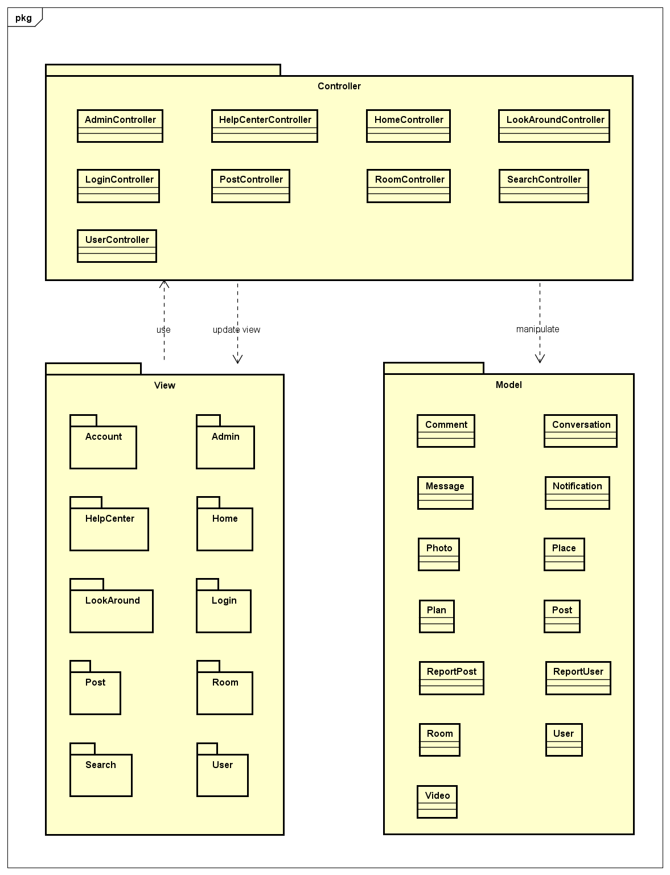

*Package Diagram*

## Package Description

### Model

#### Comment

|  |  |  |  |  |  |
| --- | --- | --- | --- | --- | --- |
| No | Attributes | Type | Default | Note | Description |
|  | commentID | int |  |  | Comment’s ID |
|  | content | String |  |  | Comment’s content |
|  | dateCreated | String |  |  | Comment’s created date. Auto-created while uploading |

#### Conversation

|  |  |  |  |  |  |
| --- | --- | --- | --- | --- | --- |
| No | Attributes | Type | Default | Note | Description |
|  | conversationID | String |  | public | Conversation’s ID |
|  | dateCreated | String |  | public | Conversation’s created date. Auto-created while creating conversation |

#### Message

|  |  |  |  |  |  |
| --- | --- | --- | --- | --- | --- |
| No | Attributes | Type | Default | Note | Description |
|  | messageID | int |  | public | Message’s ID |
|  | content | String |  | public | Message’s content |
|  | dateCreated | String |  | public | Message’s created date. Auto-created while creating conversation |

#### Notification

|  |  |  |  |  |  |
| --- | --- | --- | --- | --- | --- |
| No | Attributes | Type | Default | Note | Description |
|  | activity | String |  | public | Activity type of notification |
|  | dateCreated | String |  | public | Notification’s created date. Auto-created while creating conversation |
|  | user | user |  | public |  |
|  | post | post |  | public |  |
|  | lastActivityID | Int16 |  | public |  |

#### Photo

|  |  |  |  |  |  |
| --- | --- | --- | --- | --- | --- |
| No | Attributes | Type | Default | Note | Description |
|  | photoID | int |  |  | Photo’s ID |
|  | url | String |  |  | Photo’s URL |
|  | dateCreated | String |  |  | Photo’s created date. Auto-created while uploading |

#### Place

|  |  |  |  |  |  |
| --- | --- | --- | --- | --- | --- |
| No | Attributes | Type | Default | Note | Description |
|  | placeID | int |  |  | Place’s ID |
|  | name | String |  |  | Place’s name |
|  | latitude | Decimal |  |  | Place’s latitude |
|  | longitude | Decimal |  |  | Place’s longitude |

#### Plan

|  |  |  |  |  |  |
| --- | --- | --- | --- | --- | --- |
| No | Attributes | Type | Default | Note | Description |
|  | PlanID | int |  |  | Plan’s ID |
|  | WorkItem | String |  |  |  |
|  | LengthInMinute | int |  |  |  |
|  | DatePlanStart | String |  |  |  |

#### Post

|  |  |  |  |  |  |
| --- | --- | --- | --- | --- | --- |
| No | Attributes | Type | Default | Note | Description |
|  | postID | int |  |  | Post’s ID |
|  | content | String |  |  | Post’s content |
|  | dateCreated | String |  |  | Post’s created date. Auto-created while creating post |
|  | privacy | String |  |  | Post’s privacy |

#### Room

|  |  |  |  |  |  |
| --- | --- | --- | --- | --- | --- |
| No | Attributes | Type | Default | Note | Description |
|  | RoomID | int |  | public | Room’s ID |
|  | RoomName | String |  | public | Room name |
|  | Description | String |  | public | Room’s description |
|  | DateCreated | String |  | public | Room’s created date. Auto-created while creating room |
|  | StartDate | String |  | public | Start date of room’s plan |
|  | LengthInDays | int |  | public | Length of room’s plan |
|  | MaxNoSlot | int |  | public | Number of room’s member |
|  | StartLocation | String |  | public | Start location of room’s plan |
|  | StartLatitude | String |  | public | Latitude of start location |
|  | StartLongitude | String |  | public | Longitude of start location |
|  | DestinationLocation | String |  | public | Destination location of room’s plan |
|  | DestinationLatitude | String |  | public | Latitude of destination location |
|  | DestinationLongitude | String |  | public | Longitude of destination location |
|  | Privacy | String |  | public | Room’s privacy |
|  | PhotoCoverUrl | String |  | public | Room’s cover photo URL |

#### User

|  |  |  |  |  |  |
| --- | --- | --- | --- | --- | --- |
| No | Attributes | Type | Default | Note | Description |
|  | userID | int |  | public | User’s ID |
|  | typeID | int |  | public | User’s type, includes: Normal, Facebook, Google+ registered |
|  | address | String |  | public | User’s address |
|  | avatar | String |  | public | User’s avatar image |
|  | dateJoined | String |  | public | User’s joined date. Auto-created while registering |
|  | dateOfBirth | String |  | public | User’s date of birth |
|  | email | String |  | public | User’s email |
|  | firstName | String |  | public | User’s first name |
|  | lastName | String |  | public | User’s last name |
|  | password | String |  | public | User’s password |
|  | phoneNumber | String |  | public | User’s phone number |
|  | status | String |  | public | User’s status, includes: Lock and Active |

#### Video

|  |  |  |  |  |  |
| --- | --- | --- | --- | --- | --- |
| No | Attributes | Type | Default | Note | Description |
|  | videoID | int |  | public | Video’s ID |
|  | path | String |  | public | Video’s URL |
|  | dateCreated | String |  | public | Video’s created date. Auto-created while creating video |

### View

* Contain many .cshtml files to display user interface.

### Controller

#### AdminController

|  |  |  |  |  |
| --- | --- | --- | --- | --- |
| No. | Method | Parameter | Return | Description |
|  | Authenticate |  | ActionResult |  |
|  | Index |  | ActionResult | Display Admin page |
|  | LockUser | int, int | JsonResult | Lock a reported user |
|  | UnlockUser | int | JsonResult | Unlock a locked user |
|  | LockPost | int, int | JsonResult | Lock a reported post |
|  | CancelReportPost | int | JsonResult | Delete a post from report list |
|  | CancelReportUser | int | JsonResult | Delete an user from report list |
|  | ViewPost | int | ActionResult |  |

#### HelpCenterController

|  |  |  |  |  |
| --- | --- | --- | --- | --- |
| No. | Method | Parameter | Return | Description |
|  | Index |  | ActionResult | Display Help Center page |

#### LoginController

|  |  |  |  |  |
| --- | --- | --- | --- | --- |
| No. | Method | Parameter | Return | Description |
|  | AuthenFacebook |  |  | User login with Facebok |
|  | AuthenGoogle |  |  | User login with Google+ |
|  | ForgotPassword |  |  | Set user’s password to a random string and send to user |
|  | Login |  |  | User login with registered account |
|  | Logout |  |  | User logout from FAP |
|  | SendMail |  |  | Send mail to user |

#### LookAroundController

|  |  |  |  |  |
| --- | --- | --- | --- | --- |
| No. | Method | Parameter | Return | Description |
|  | Index |  | ActionResult | Display Look Around page |

#### PostController

|  |  |  |  |  |
| --- | --- | --- | --- | --- |
| No. | Method | Parameter | Return | Description |
|  | Index |  | ActionResult | Display Post Detail page |
|  | CreatePost | form | ActionResult | Create a post |
|  | EditPost | int, String | void | Edit an own existed post |
|  | DeletePost | int | void | Delete an own existed post |

#### RoomController

|  |  |  |  |  |
| --- | --- | --- | --- | --- |
| No. | Method | Parameter | Return | Description |
|  | Index | int | ActionResult | Display Room Detail page |
|  | RoomDetail | String | ActionResult | Display room detail |
|  | UpdateEventPlan | String, String, String | void | Update plan of a room |
|  | SaveEvent | String, String, String, String | Boolean |  |
|  | GetPlanEvents | DateTime, DateTime | JsonResult |  |
|  | Add |  | ActionResult | Create a new room |

#### SearchController

|  |  |  |  |  |
| --- | --- | --- | --- | --- |
| No. | Method | Parameter | Return | Description |
|  | Index |  | ActionResult | Display Search page |
|  | Search | String | ActionResult | Search a keyword |
|  | SearchDetail |  | ActionResult | Display Search Result page |

#### UserController

|  |  |  |  |  |
| --- | --- | --- | --- | --- |
| No. | Method | Parameter | Return | Description |
|  | AddFriend | int, int | JsonResult | Add other users to friend list to get news, notification and messages |
|  | AddToWishlist | String | JsonResult | Add a post to wish list |
|  | Comment | int, String | ActionResult | Create a comment |
|  | CreateMessage | int, String | JsonResult | Send message to others |
|  | CreateMessageInRoom | int, String | JsonResult | Create message in room |
|  | DeleteComment | int | JsonResult | Delete an owned comment |
|  | Dislike | int | JsonResult | Mark a post as dislike |
|  | EditComment | int, String | JsonResult | Edit content of an owned comment |
|  | EditProfile | user | JsonResult | Edit personal information |
|  | Like | int | JsonResult | Mark a post as liked |
|  | RemoveFromWishlist | int | JsonResult | Remove a post from wish list |
|  | ReportPost | int, int, int | JsonResult | Report a rule violation post |
|  | ReportUser | int, int | JsonResult | Report a rule violation user |
|  | Unfriend | int, int | JsonResult | Remove an user from friend list |

# Function

## Search

### Class Diagram

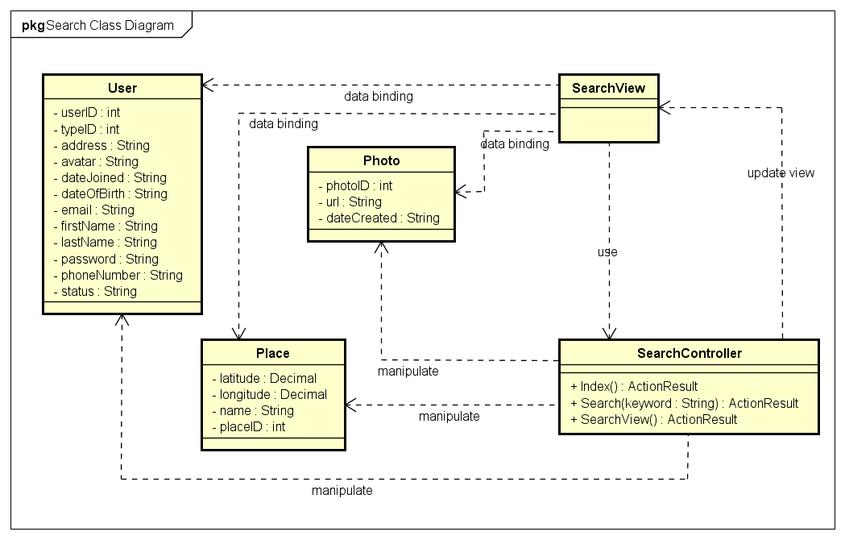

Figure 1: Search class diagram

|  |  |  |
| --- | --- | --- |
| **No.** | **Class Name** | **Description** |
|  | User | Include method interact with Database |
|  | Photo | Include method interact with Database |
|  | Place | Include method interact with Database |
|  | Search | Include method interact with Controller |
|  | Search Controller | Include method interact with Model |

### Sequence Diagram

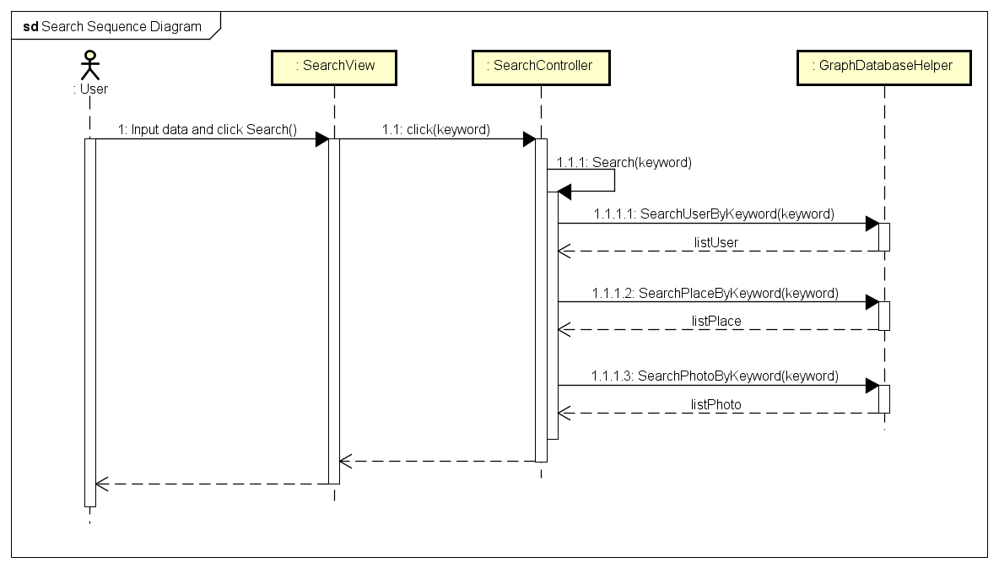

*Figure 2: Search sequence diagram*

## Help Center

### Class Diagram

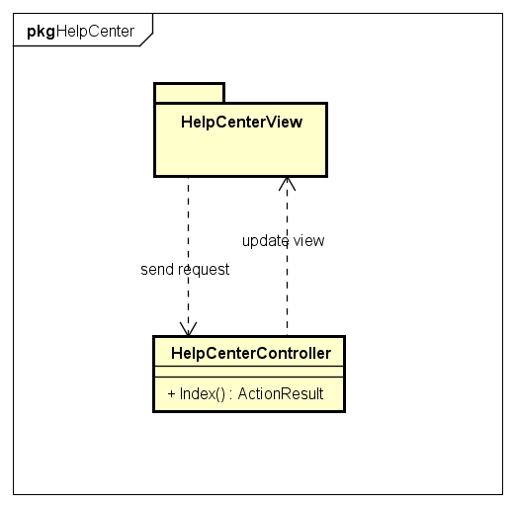

*Figure 3: Help Center class diagram*

### Sequence Diagram

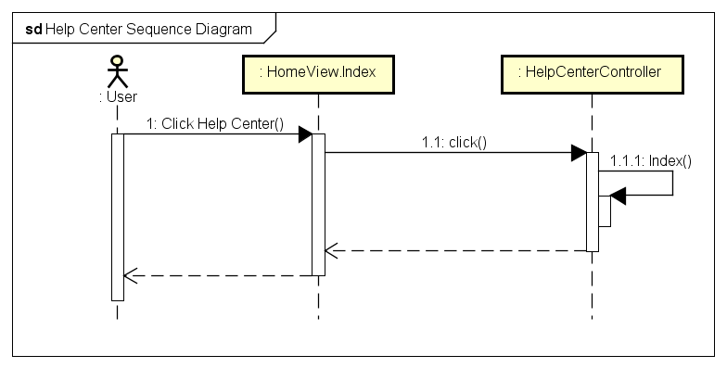

*Figure 4: Help Center sequence diagram*

## Suggest

### Class Diagram

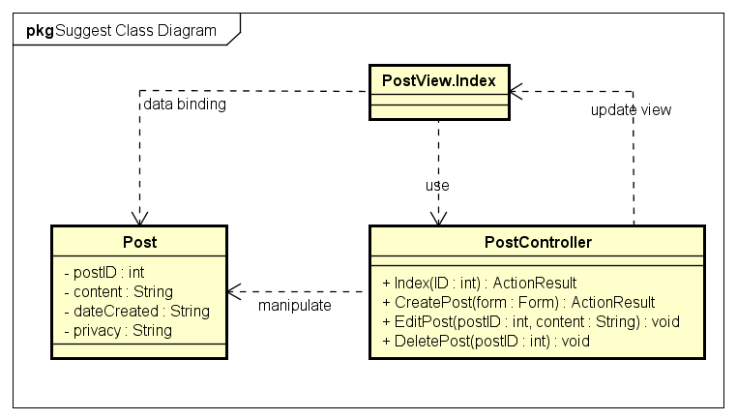

Figure 5: Suggest class diagram

### Sequence Diagram

#### Suggest Friend

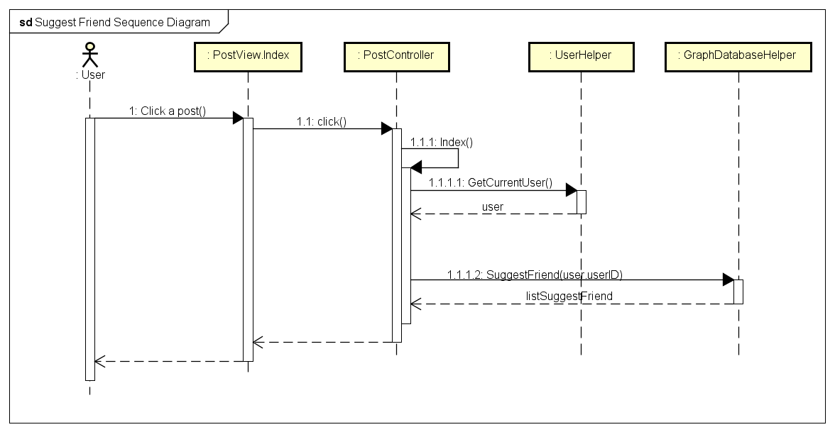

Figure 6: Suggest Friend sequence diagram

#### Suggest Place

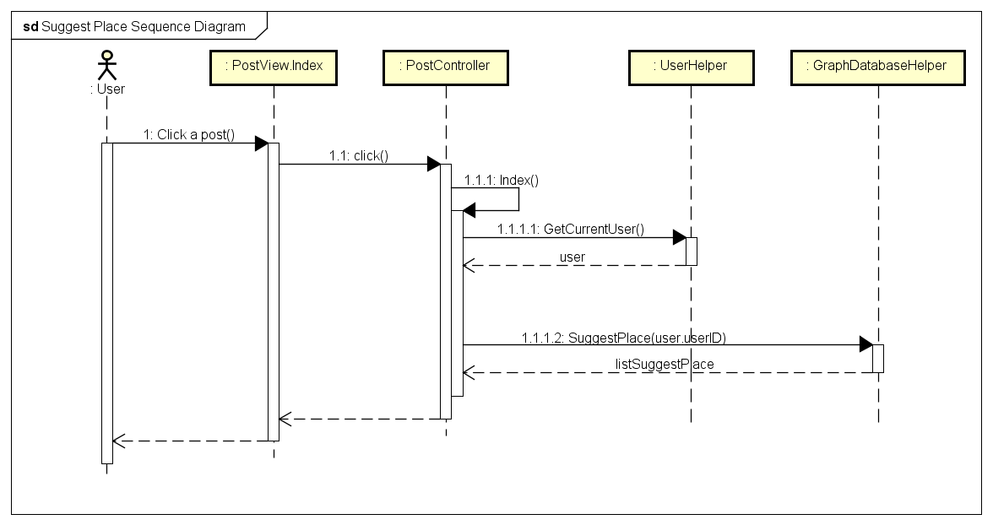

Figure 7: Suggest Place sequence diagram

## Personal Page

### Class diagram

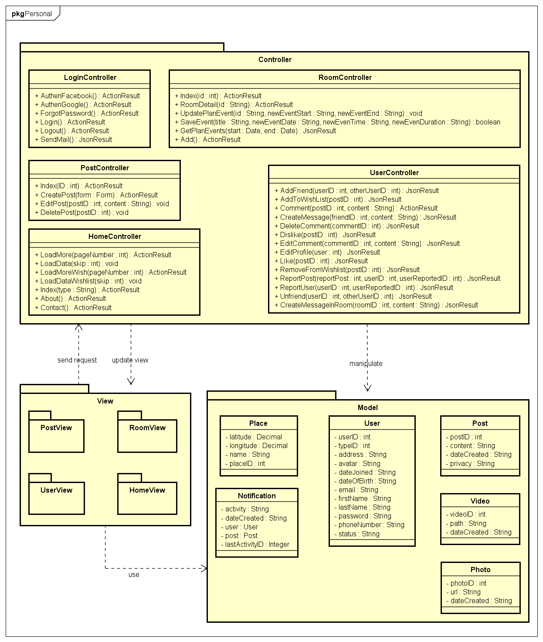

*Figure 8: Personal Page sequence diagram*

### Sequence Diagram

#### Display User’s Personal Page

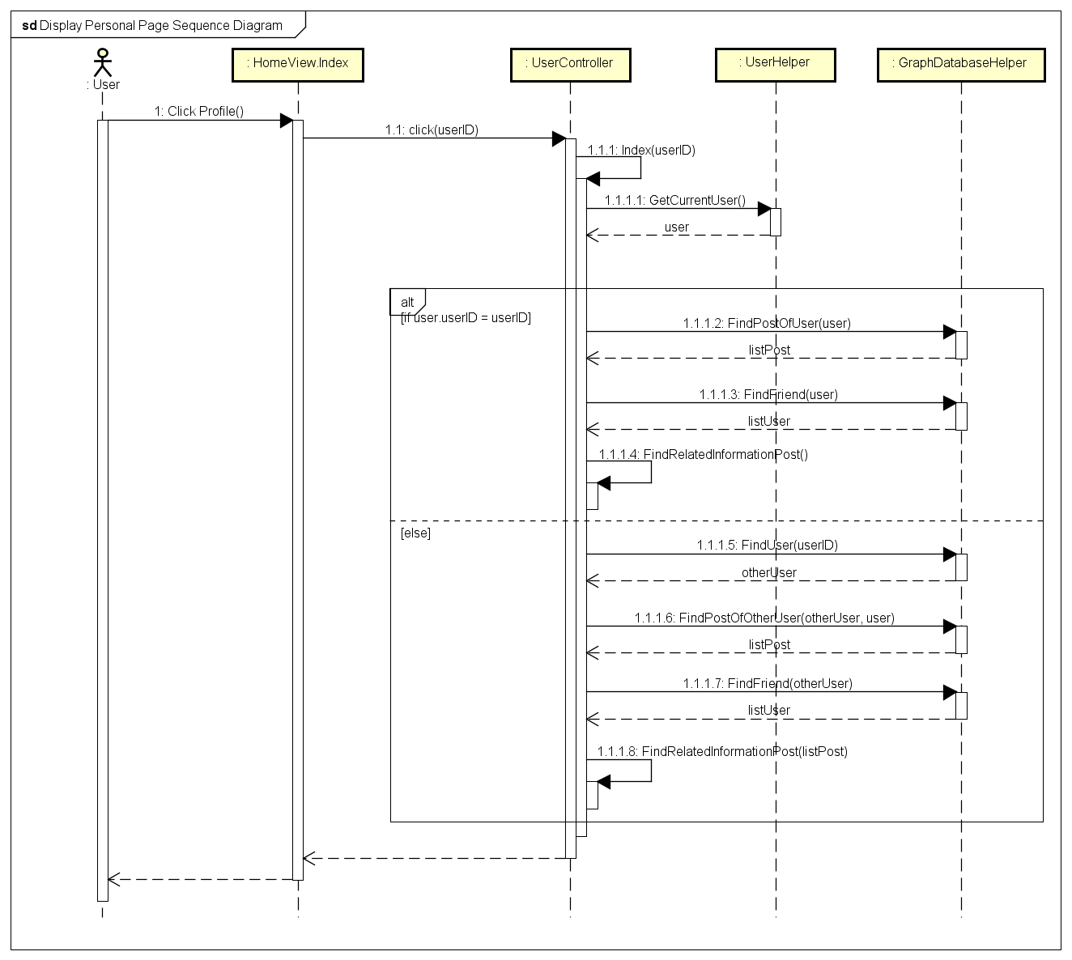

*Figure 9: Display User's Personal Page sequence diagram*

#### Display New Feed

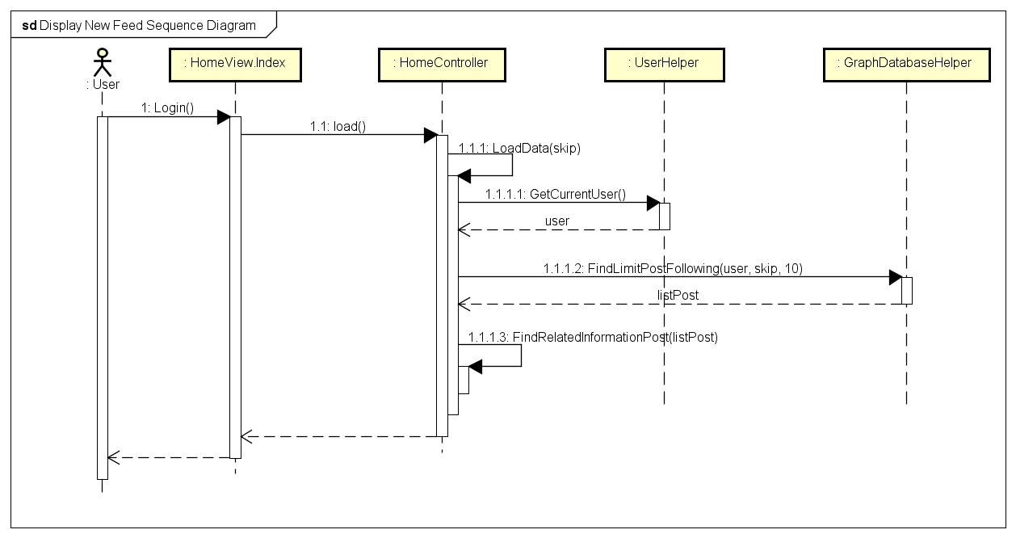

*Figure 10: Display New Feed sequence diagram*

#### Display Post Detail

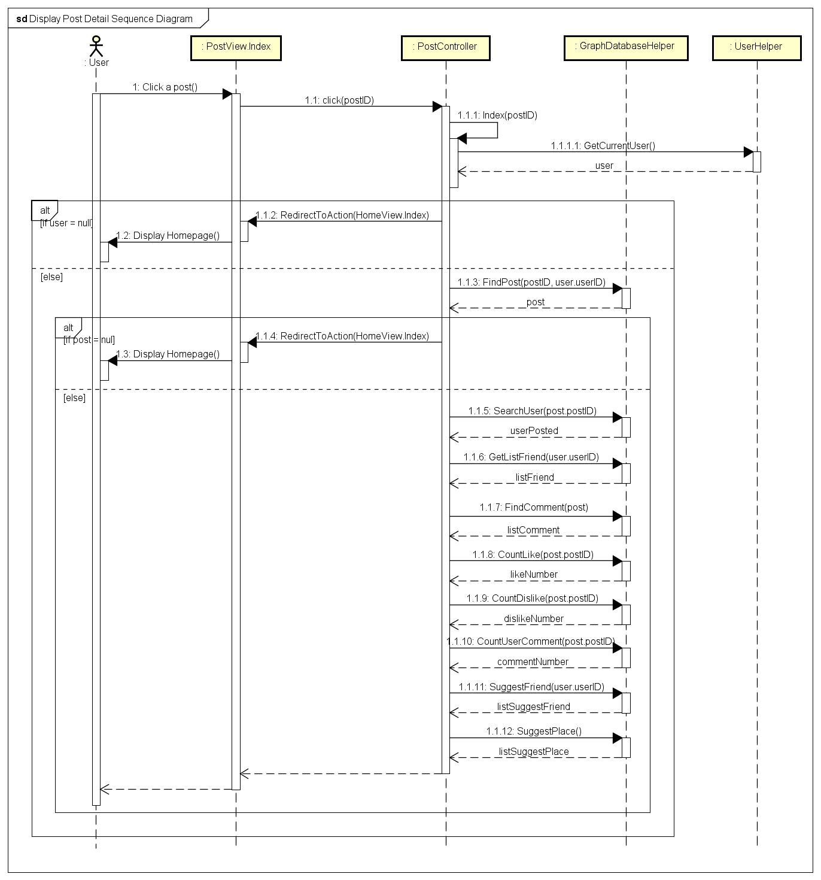

*Figure 11: Display Post Detail sequence diagram*

#### Display Wish List

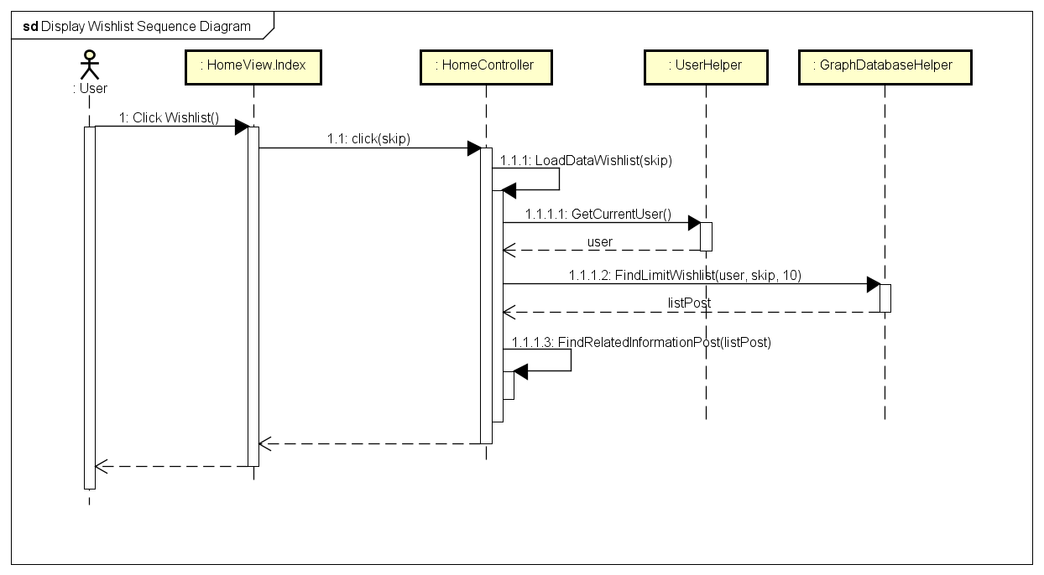

*Figure 12: Display Wish List sequence diagram*

#### Display Room List

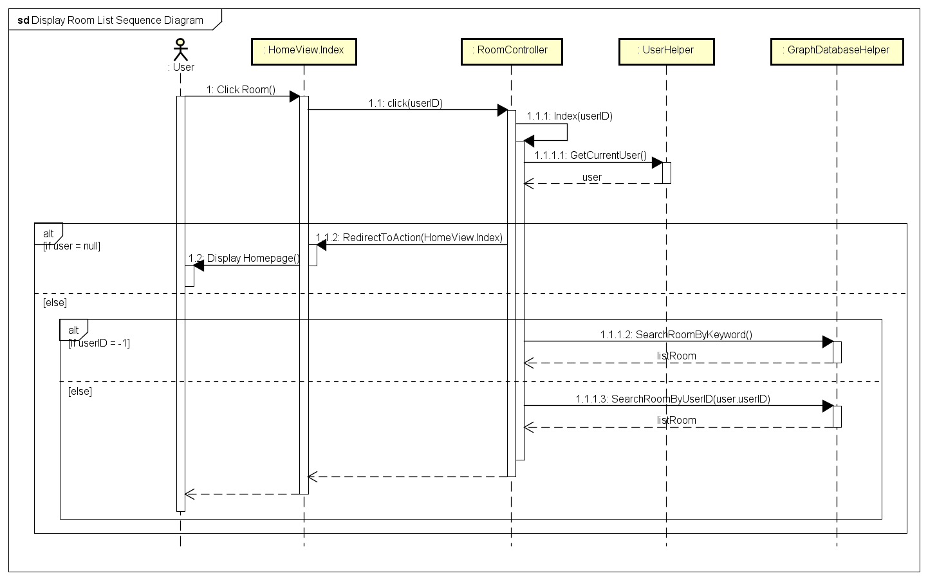

*Figure 13: Display Room List sequence diagram*

#### Display Room Detail

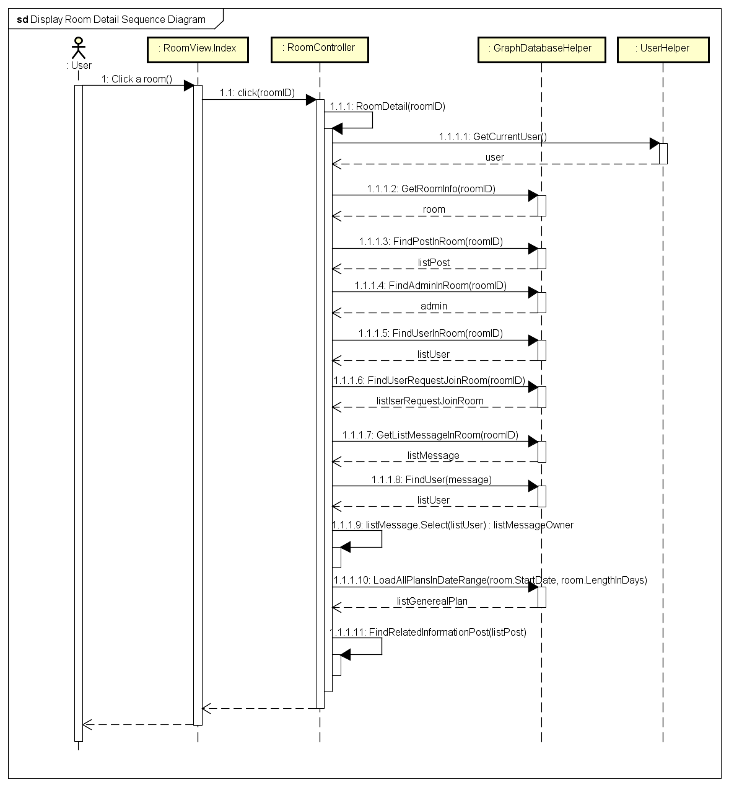

*Figure 14: Display Room Detail sequence diagram*

#### Display Photo List

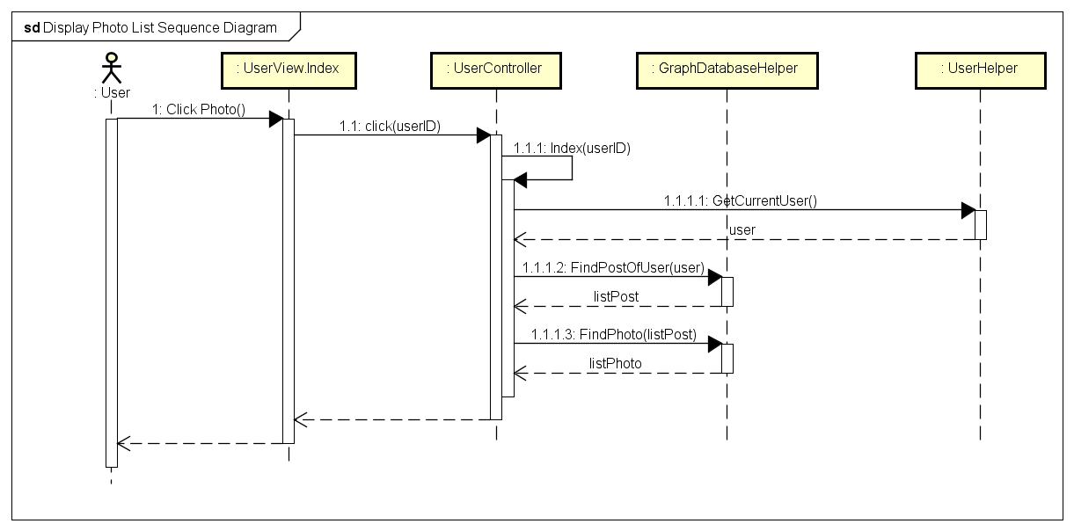

*Figure 15: Display Photo List sequence diagram*

#### Display Video List

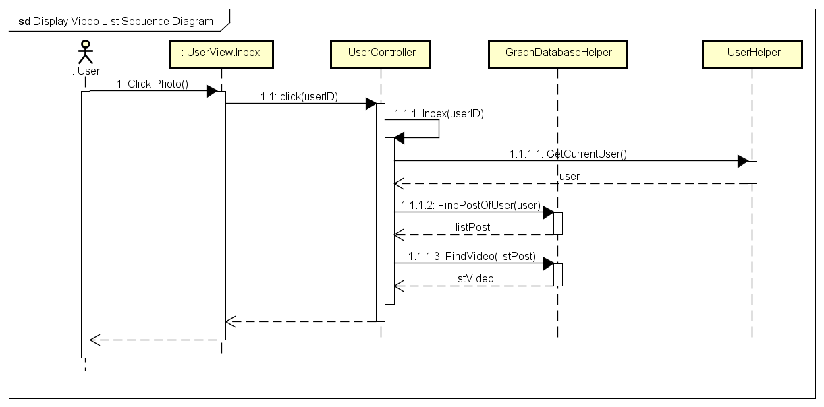

*Figure 16: Display Video List sequence diagram*

#### Display Place List

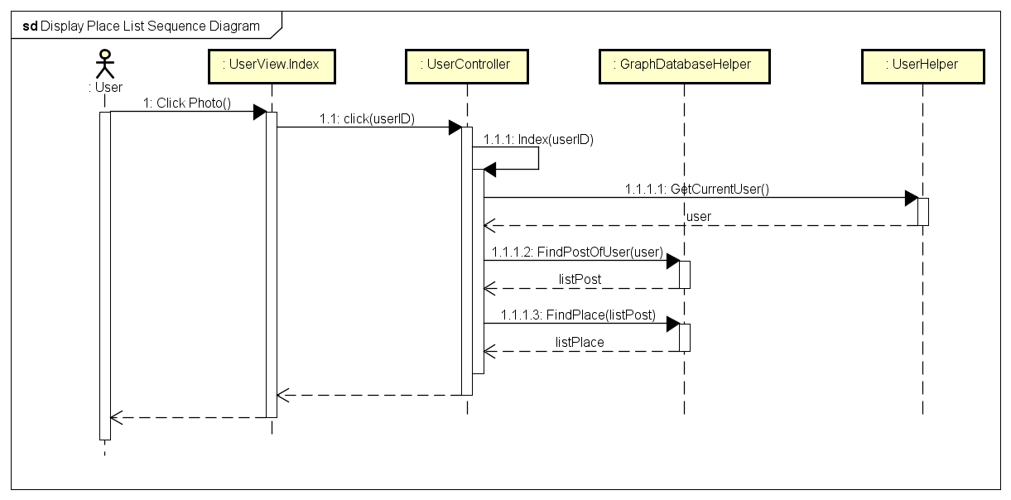

*Figure 17: Display Place List sequence diagram*

#### View Place

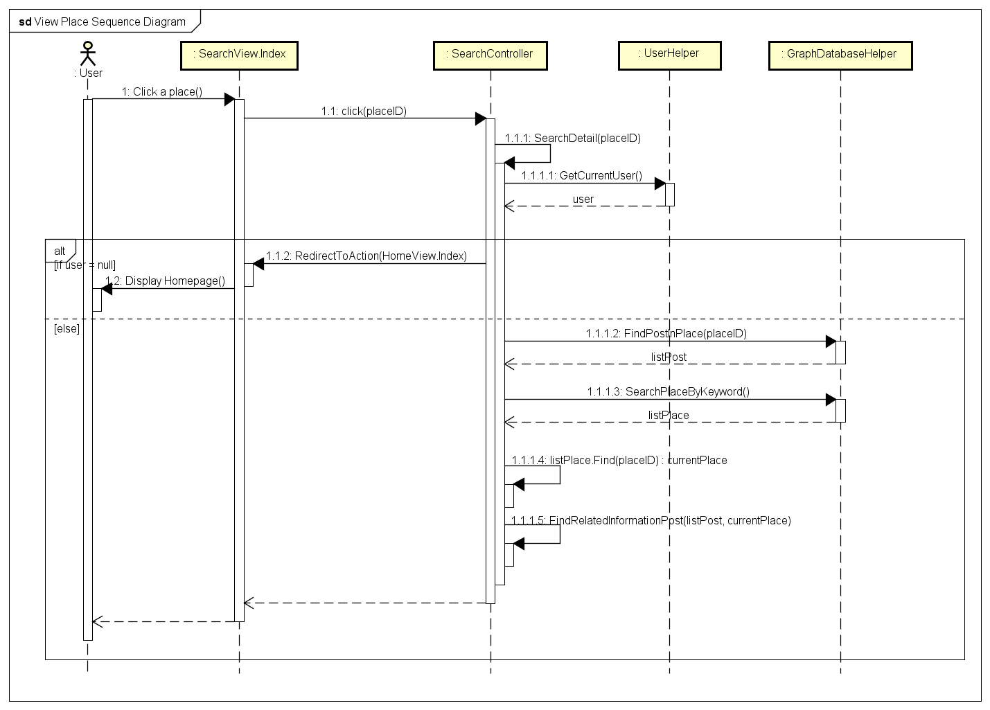

*Figure 18: View Place sequence diagram*

## Post Management

### Class Diagram

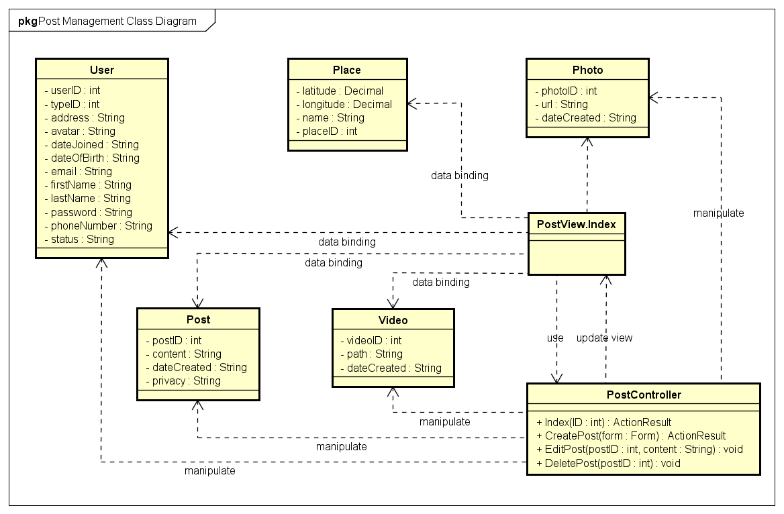

Figure 19: Post Management class diagram

|  |  |  |
| --- | --- | --- |
| No. | Class Name | Description |
|  | User | Include method interact with Database |
|  | Photo | Include method interact with Database |
|  | Place | Include method interact with Database |
|  | Index | Include method interact with Controller |
|  | Post Controller | Include method interact with Model |

### Sequence Diagram

#### Add Post

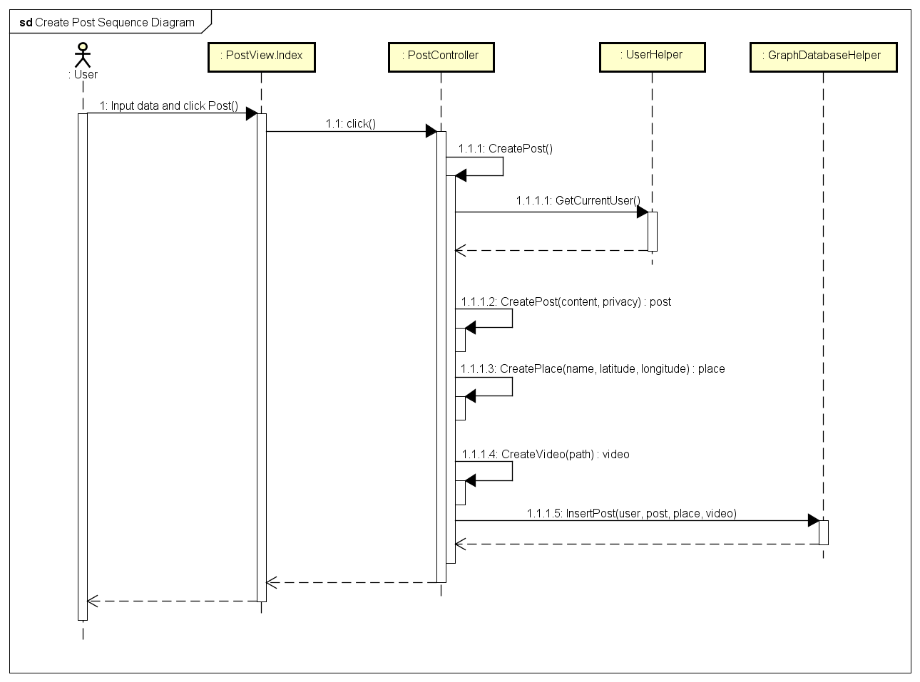

Figure 20: Add Post sequence diagram

#### Edit Post

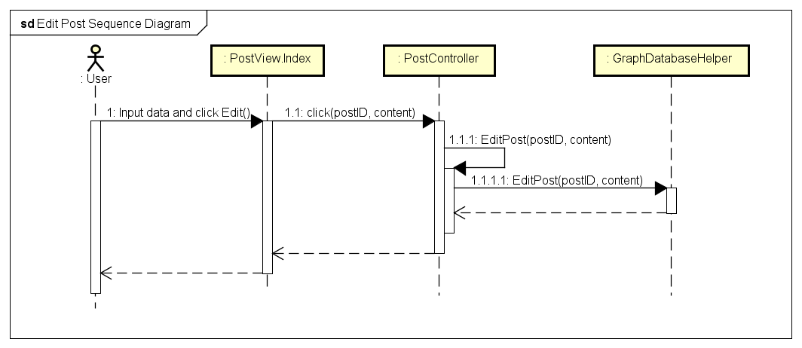

Figure 22: Edit Post sequence diagram

#### Delete Post

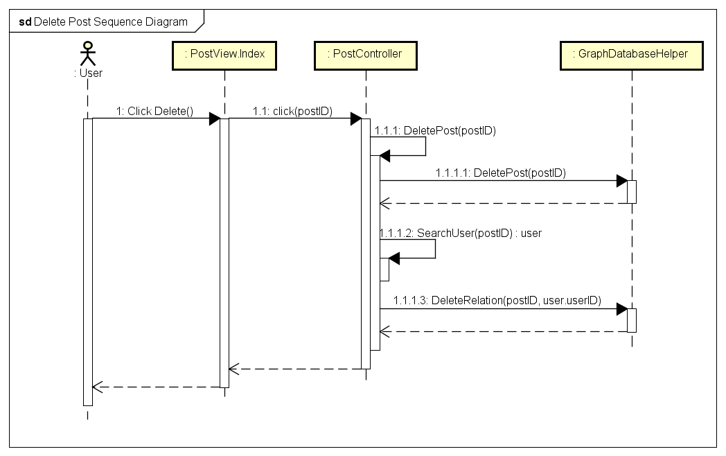

Figure 23: Delete Post sequence diagram

## Share Management

### Class Diagram

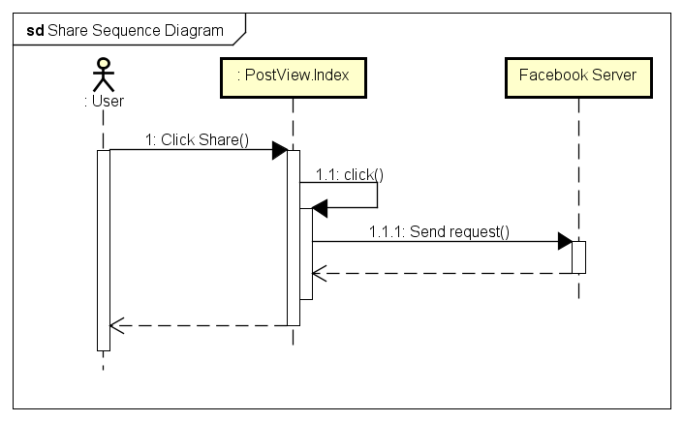

*Figure 24: Share sequence diagram*

### Sequence Diagram



*Figure 25: Share sequence diagram*

## Comment Management

### Class Diagram

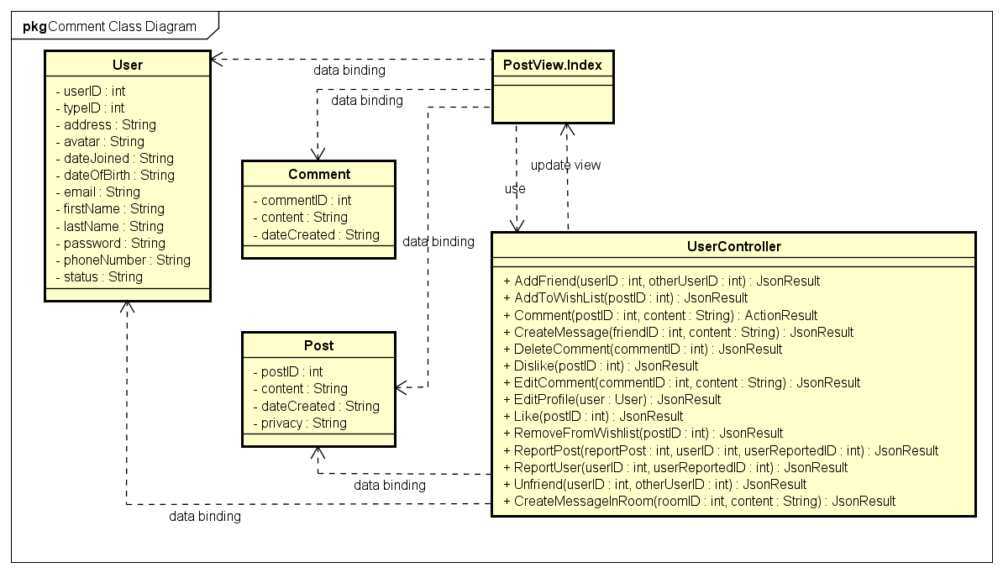

Figure 26: Comment Management class diagram

|  |  |  |
| --- | --- | --- |
| **No.** | **Class Name** | **Description** |
|  | User | Include method interact with Database |
|  | Post | Include method interact with Database |
|  | Comment | Include method interact with Database |
|  | Index | Include method interact with Controller |
|  | User Controller | Include method interact with Model |

### Sequence Diagram

#### Add Comment

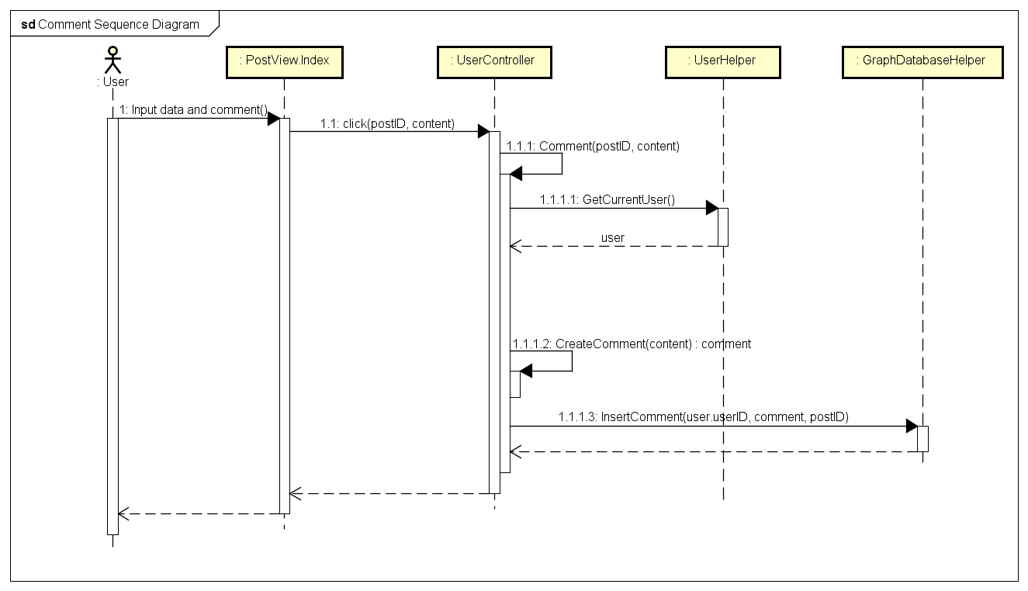

Figure 27: Add Comment sequence diagram

#### Edit Comment

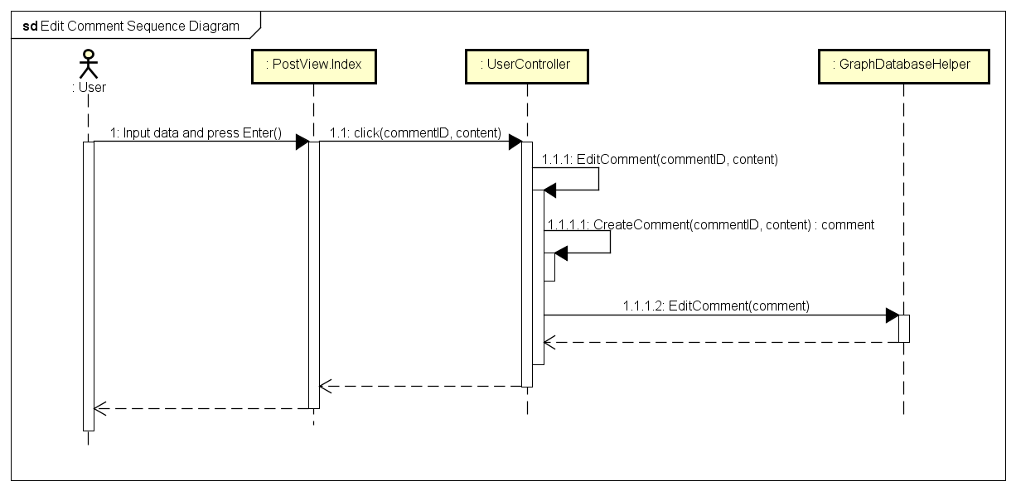

Figure 28: Edit Comment sequence diagram

#### Delete Comment

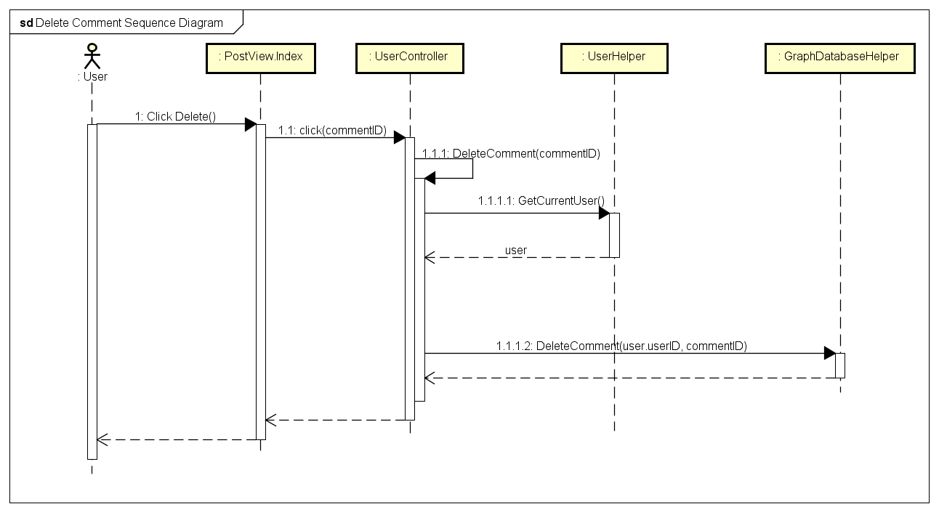

Figure 29: Delete Comment sequence diagram

## Like Management

### Class Diagram

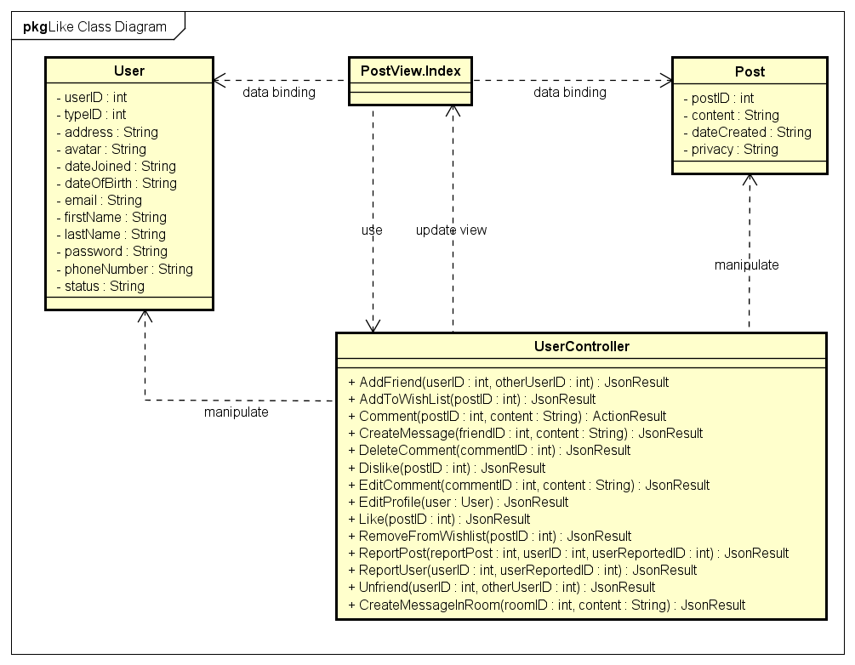

Figure 30: Like class diagram

|  |  |  |
| --- | --- | --- |
| **No.** | **Class Name** | **Description** |
|  | User | Include method interact with Database |
|  | Post | Include method interact with Database |
|  | Index | Include method interact with Controller |
|  | User Controller | Include method interact with Model |

### Sequence Diagram

#### Like

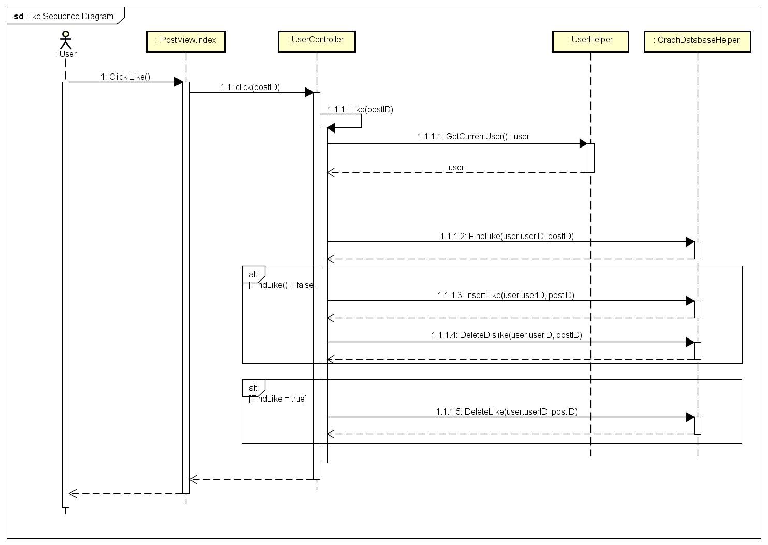

Figure 31: Like sequence diagram

#### Dislike

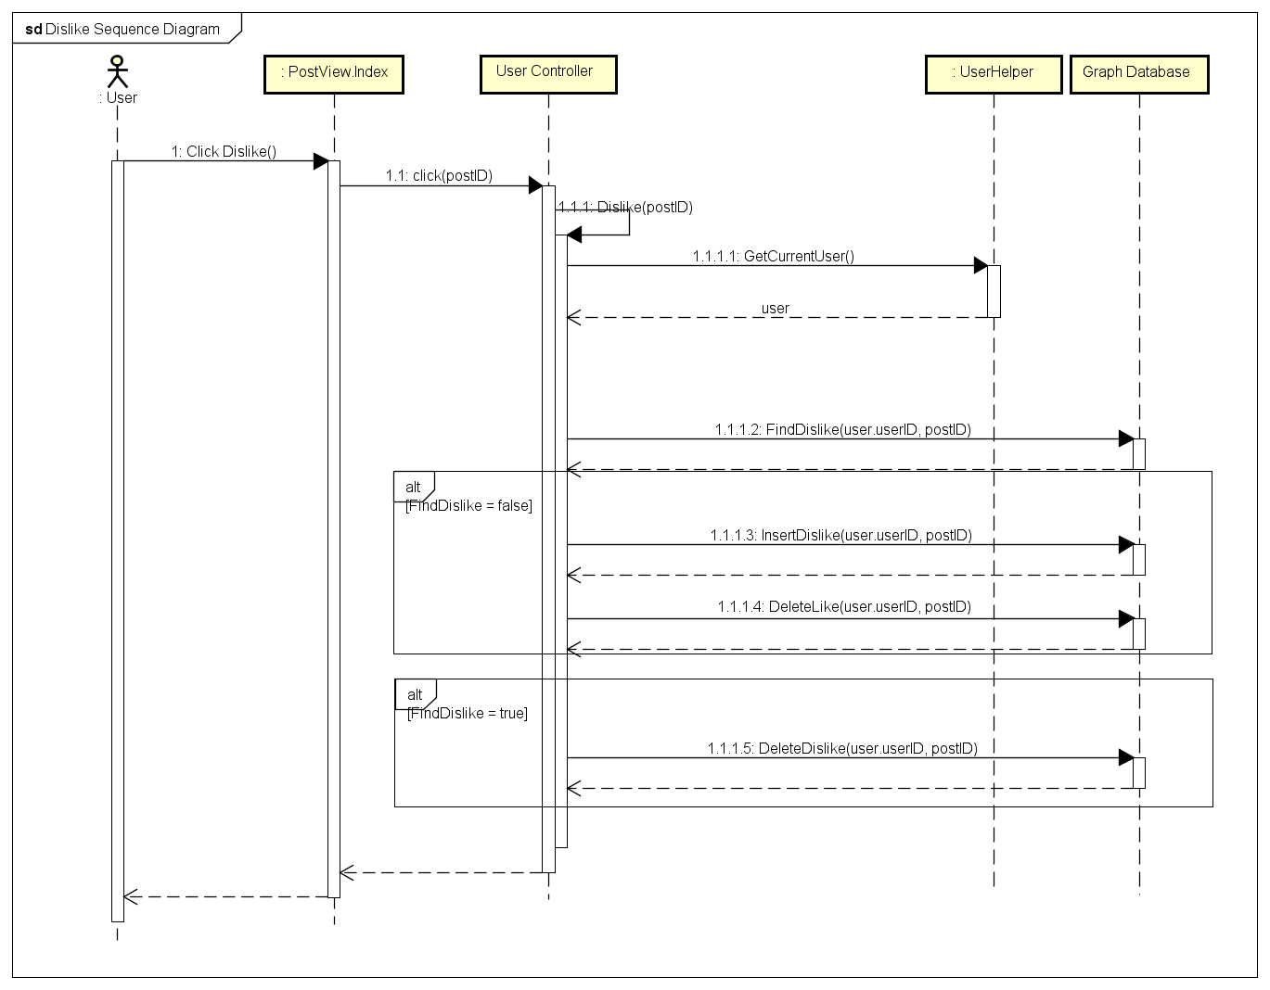

Figure 32: Dislike sequence diagram

## Report

### Class Diagram

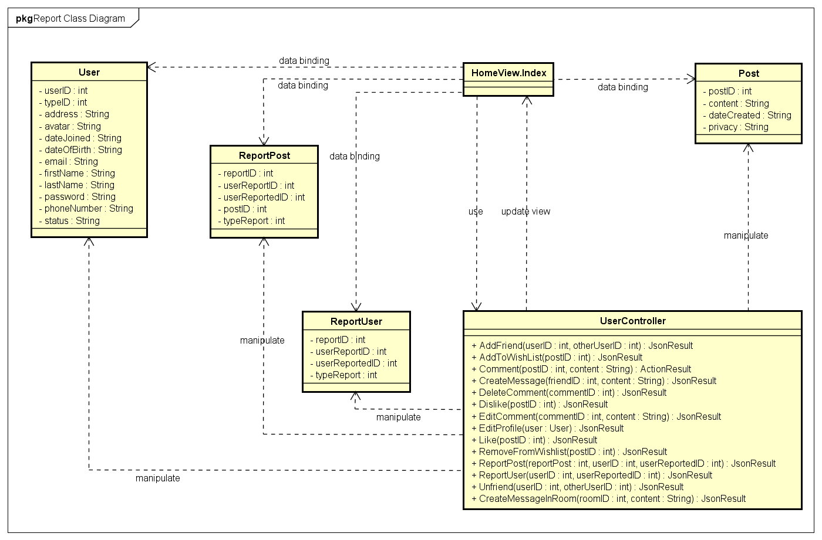

Figure 33: Report class diagram

|  |  |  |
| --- | --- | --- |
| **No.** | **Class Name** | **Description** |
|  | User | Include method interact with Database |
|  | ReportPost | Include method interact with Database |
|  | ReportUser | Include method interact with Database |
|  | Index | Include method interact with Controller |
|  | User Controller | Include method interact with Model |

### Sequence Diagram

#### Report a post

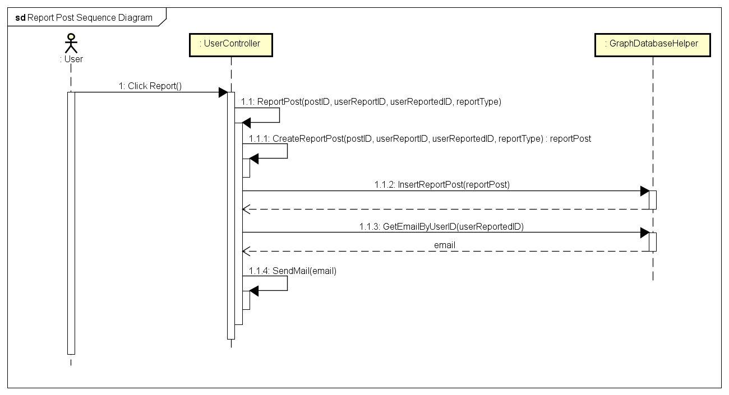

Figure 34: Report a Post sequence diagram

#### Report an user

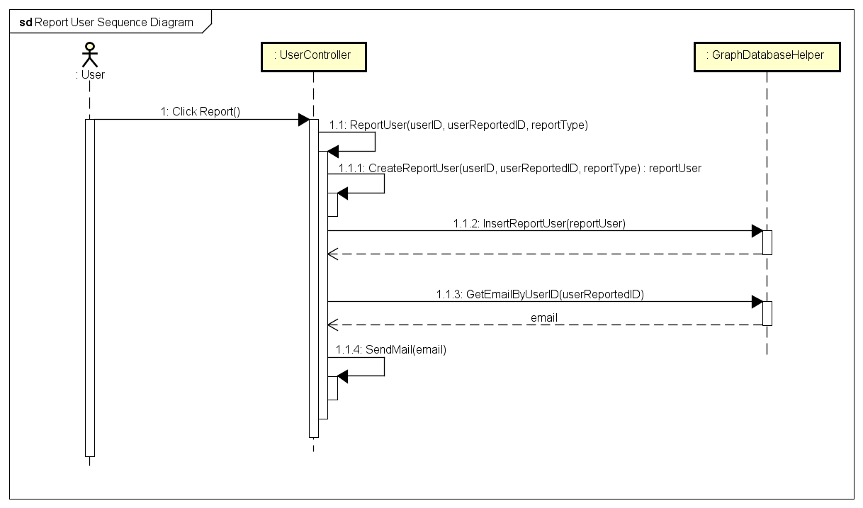

Figure 35: Report a User sequence diagram

## Chat

### Class Diagram

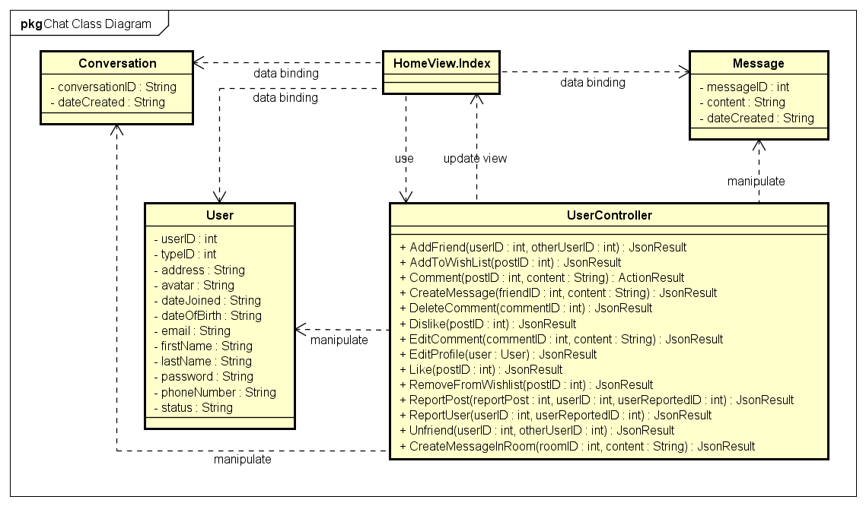

Figure 36: Chat class diagram

|  |  |  |
| --- | --- | --- |
| **No.** | **Class Name** | **Description** |
|  | User | Include method interact with Database |
|  | ReportPost | Include method interact with Database |
|  | ReportUser | Include method interact with Database |
|  | Index | Include method interact with Controller |
|  | User Controller | Include method interact with Model |

### Sequence Diagram

#### Chat

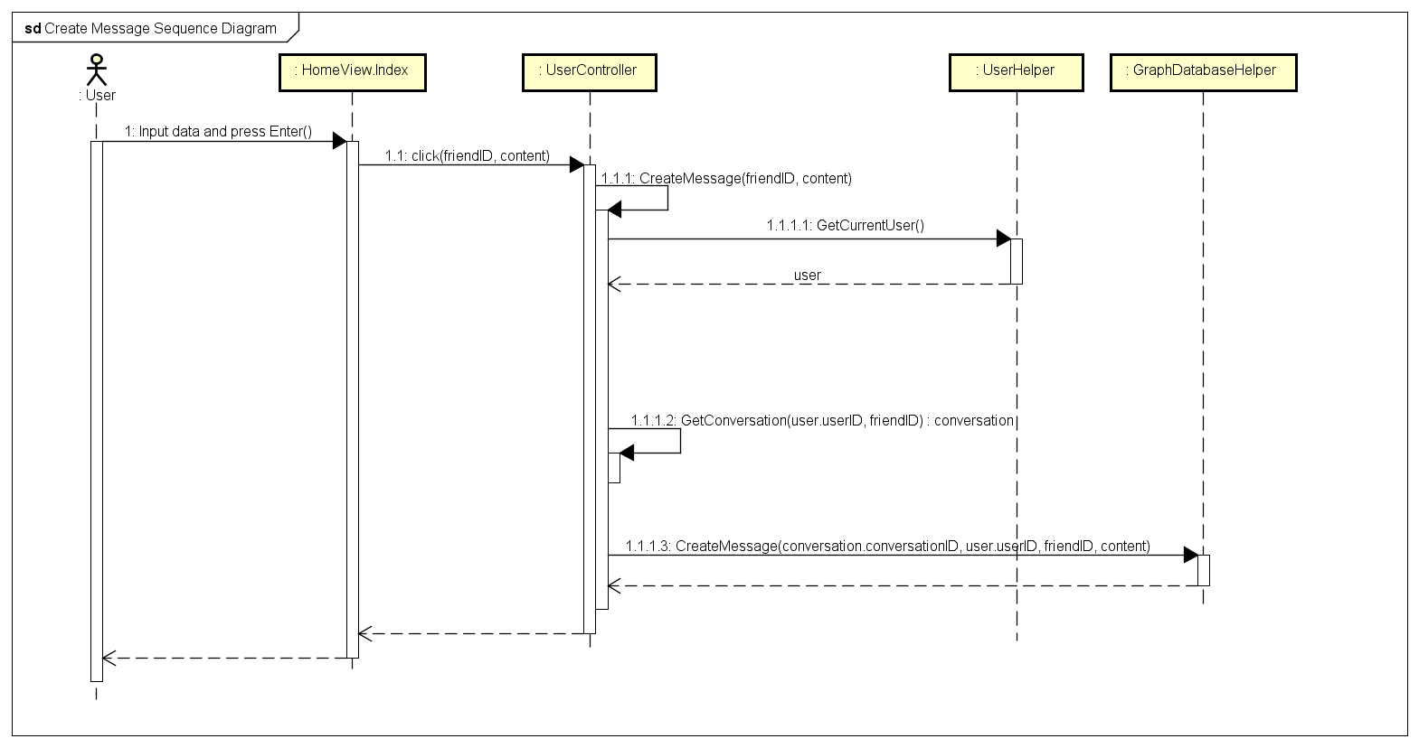

Figure 37: Chat sequence diagram

## Friend Management

### Class Diagram

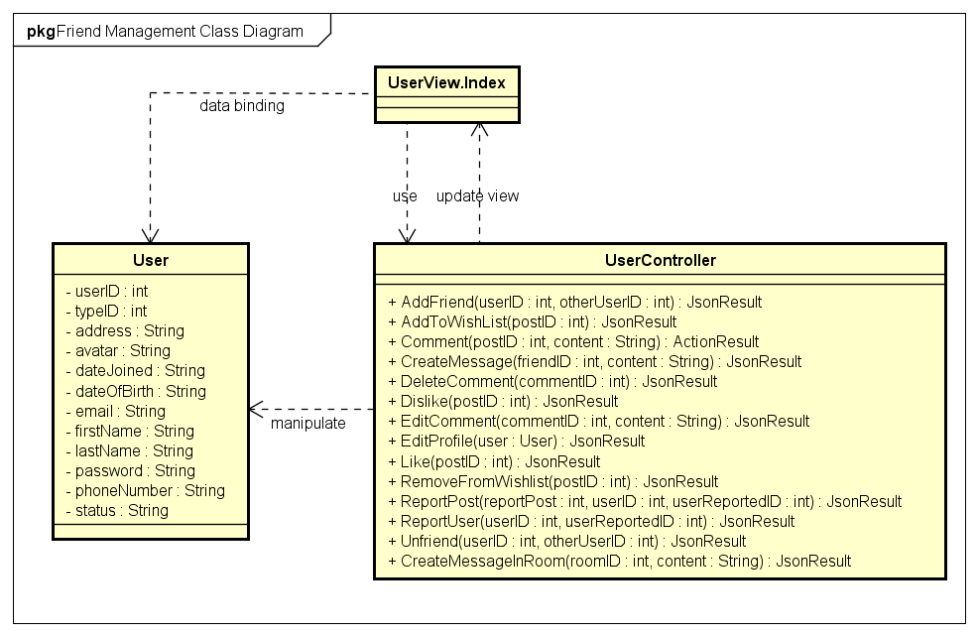

Figure 38: Friend Management class diagram

|  |  |  |
| --- | --- | --- |
| **No.** | **Class Name** | **Description** |
|  | User | Include method interact with Database |
|  | Index | Include method interact with Controller |
|  | User Controller | Include method interact with Model |

### Sequence Diagram

#### Add Friend

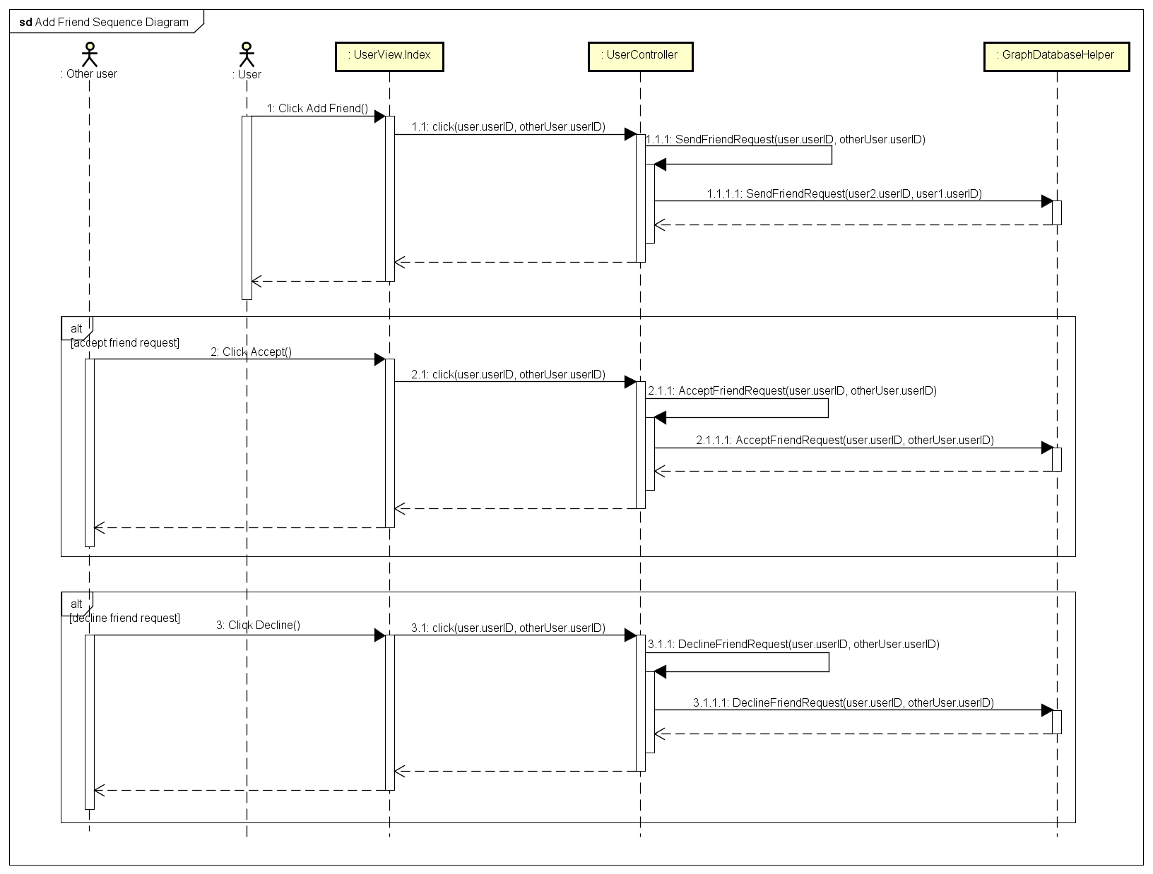

Figure 39: Add Friend sequence diagram

#### Unfriend

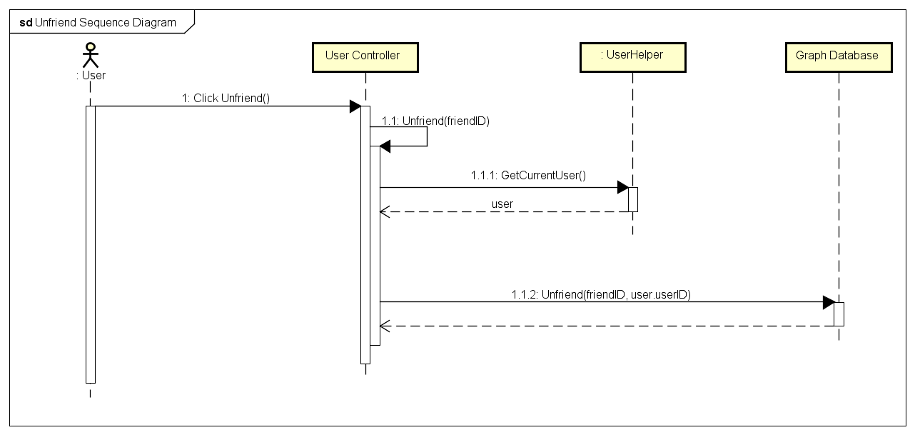

Figure 40: Unfriend sequence diagram

## Wish List

### Class Diagram

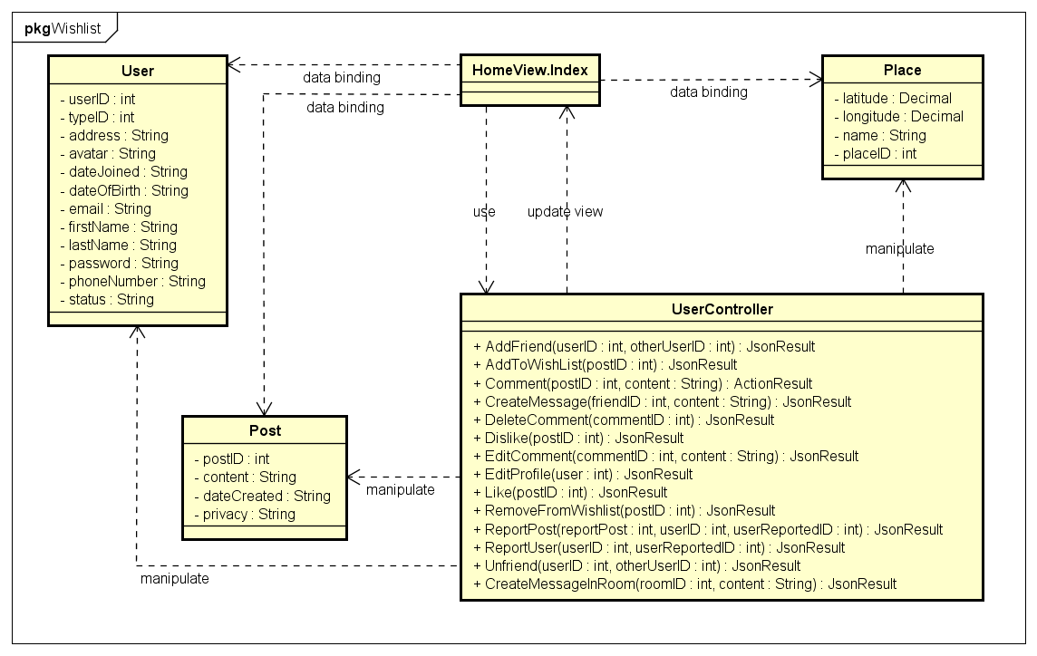

Figure 41: Wish List class diagram

|  |  |  |
| --- | --- | --- |
| **No.** | **Class Name** | **Description** |
|  | User | Include method interact with Database |
|  | Index | Include method interact with Controller |
|  | User Controller | Include method interact with Model |

### Sequence Diagram

#### Add to Wish List

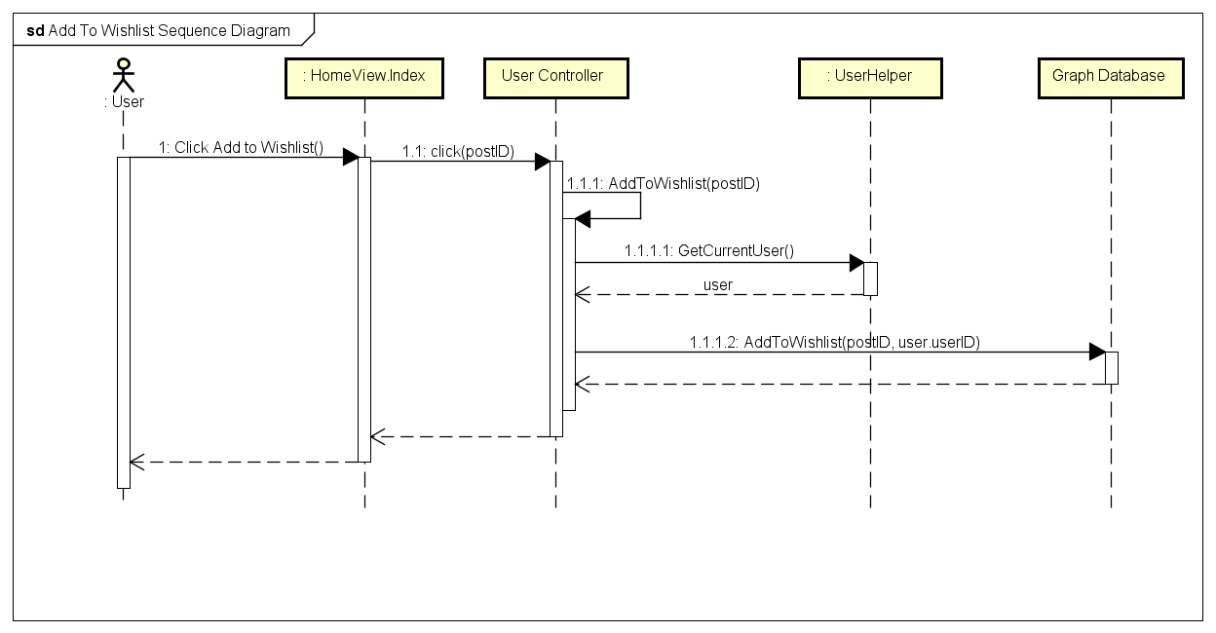

Figure 42: Add to Wish List sequence diagram

#### Remove From Wish List

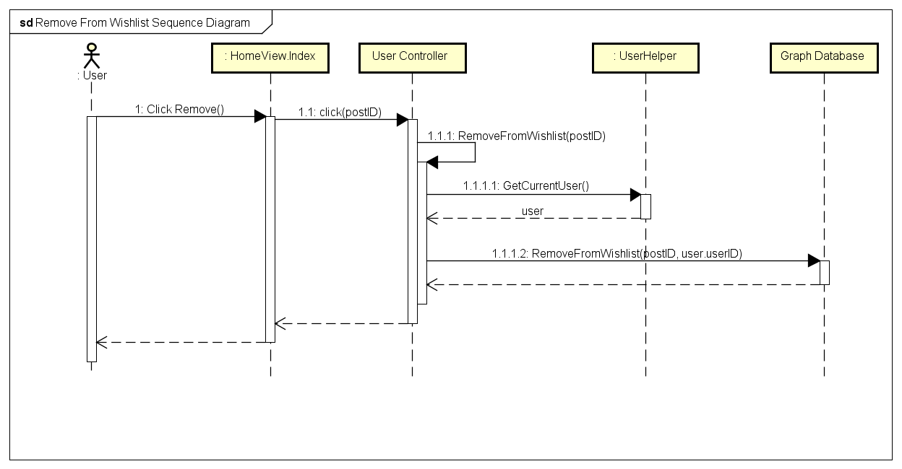

Figure 43: Remove From Wish List sequence diagram

## Room

### Class Diagram

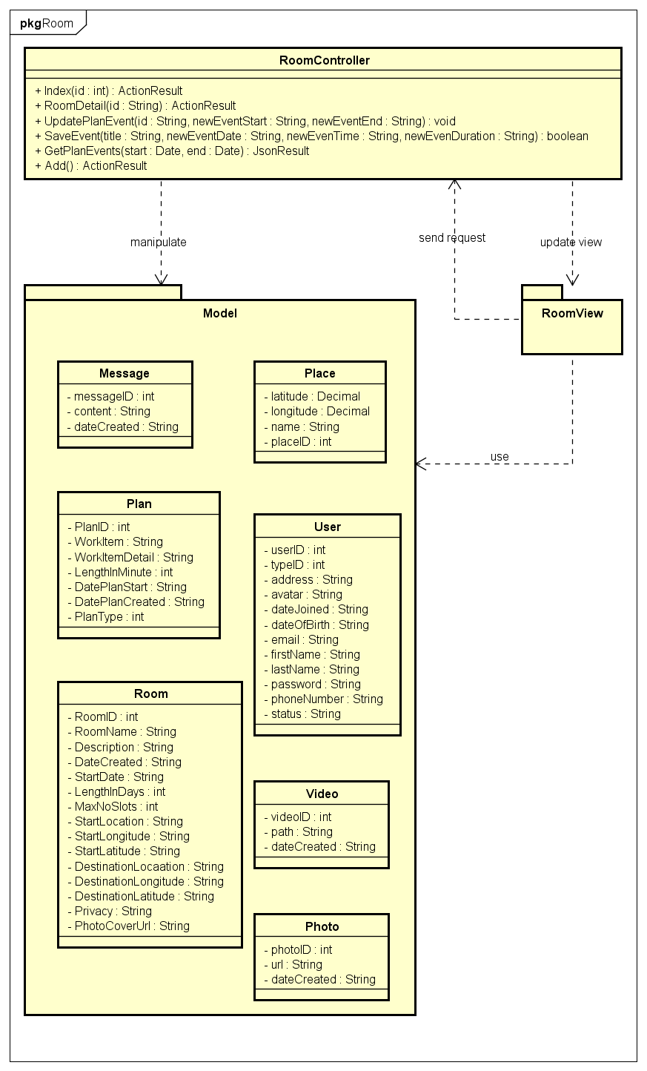

*Figure 44: Room class diagram*

### Sequence Diagram

#### Create Room

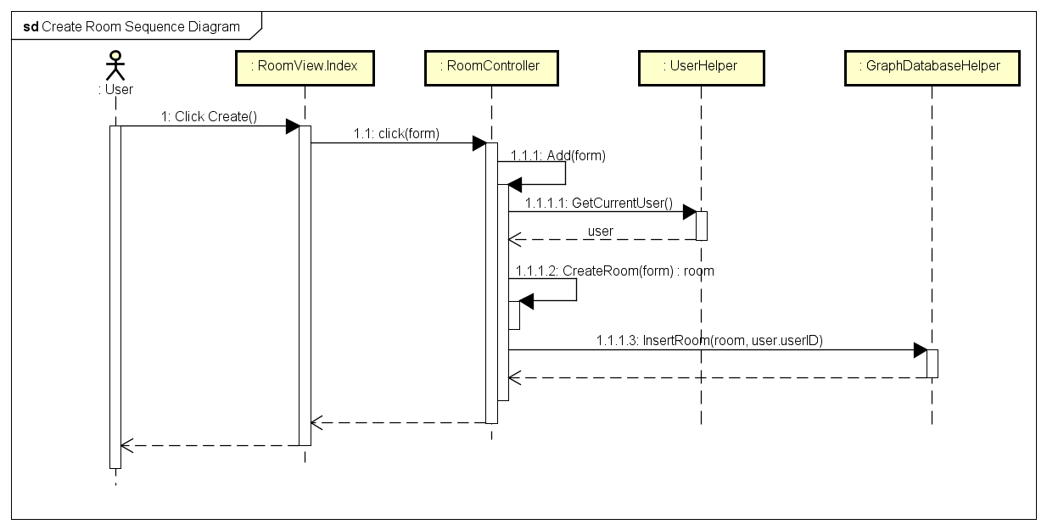

*Figure 45: Create Room sequence diagram*

#### Add General Plan

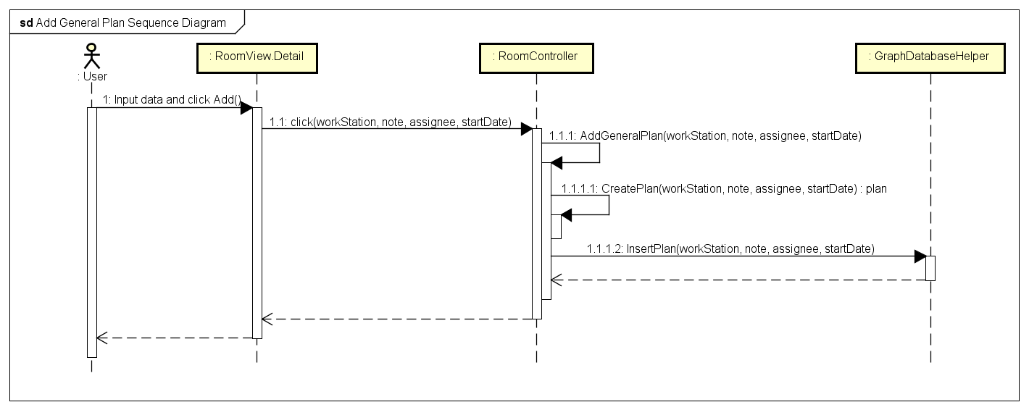

*Figure 46: Add General Plan sequence diagram*

#### Add Timeline Plan

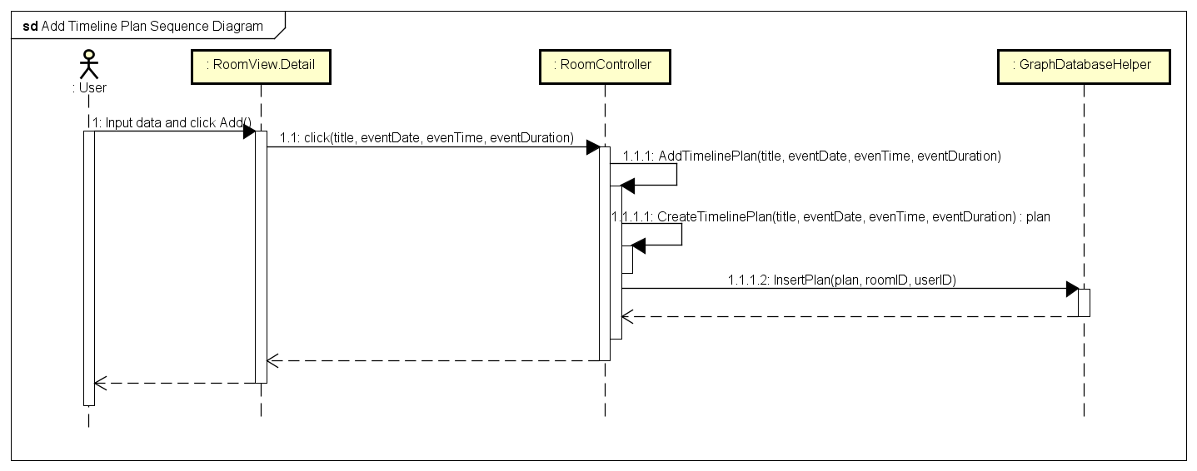

*Figure 47: Add Timeline Plan sequence diagram*

## Account Management

### Class Diagram

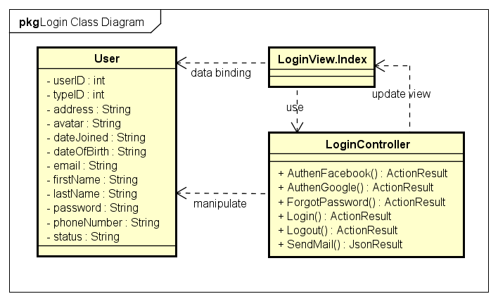

Figure 48: Account Management class diagram

|  |  |  |
| --- | --- | --- |
| **No.** | **Class Name** | **Description** |
|  | User | Include method interact with Database |
|  | Login | Include method interact with Controller |
|  | Login Controller | Include method interact with Model |

### Sequence Diagram

#### Login

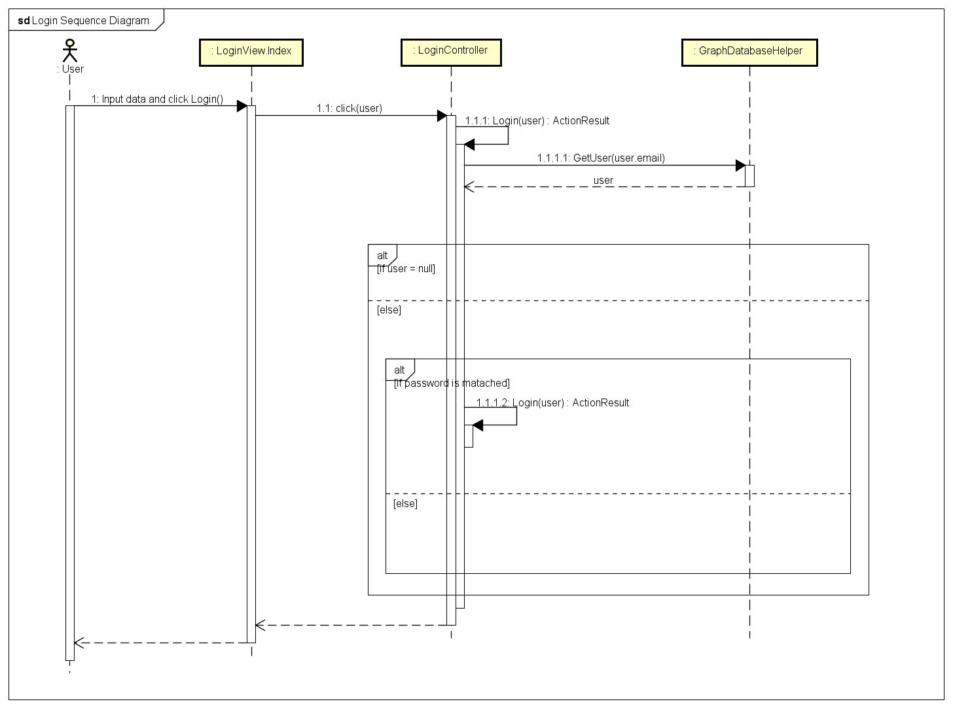

Figure 49: Login sequence diagram

#### Logout

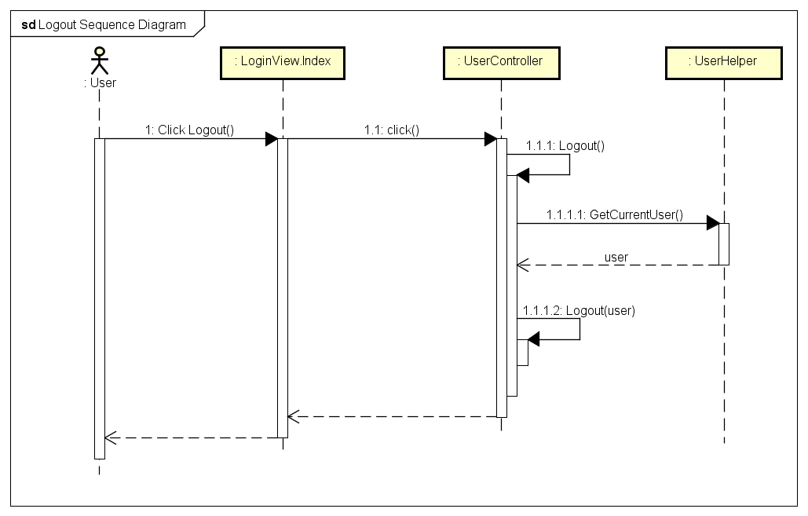

Figure 50: Logout sequence diagram

#### Register

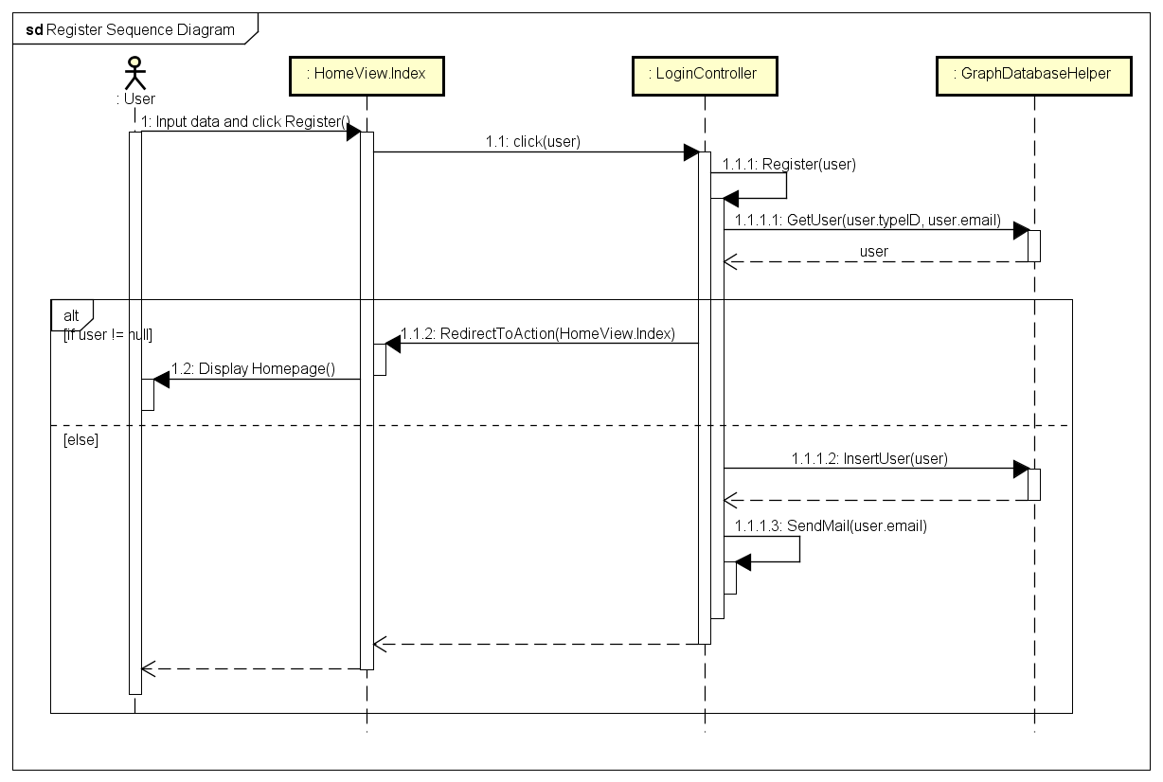

*Figure 51: Register sequence diagram*

#### Edit Profile

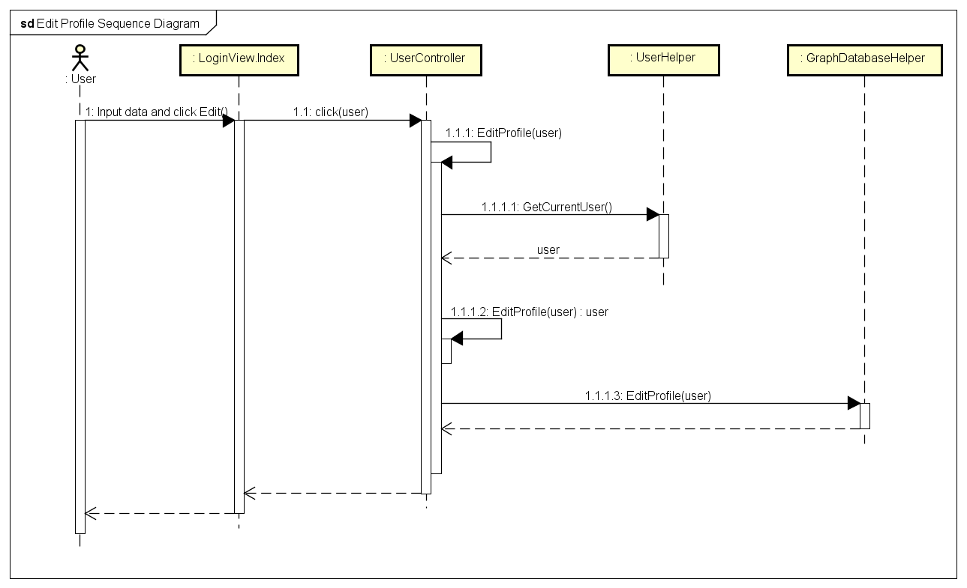

Figure 52: Edit Profile sequence diagram

#### Forgot Password

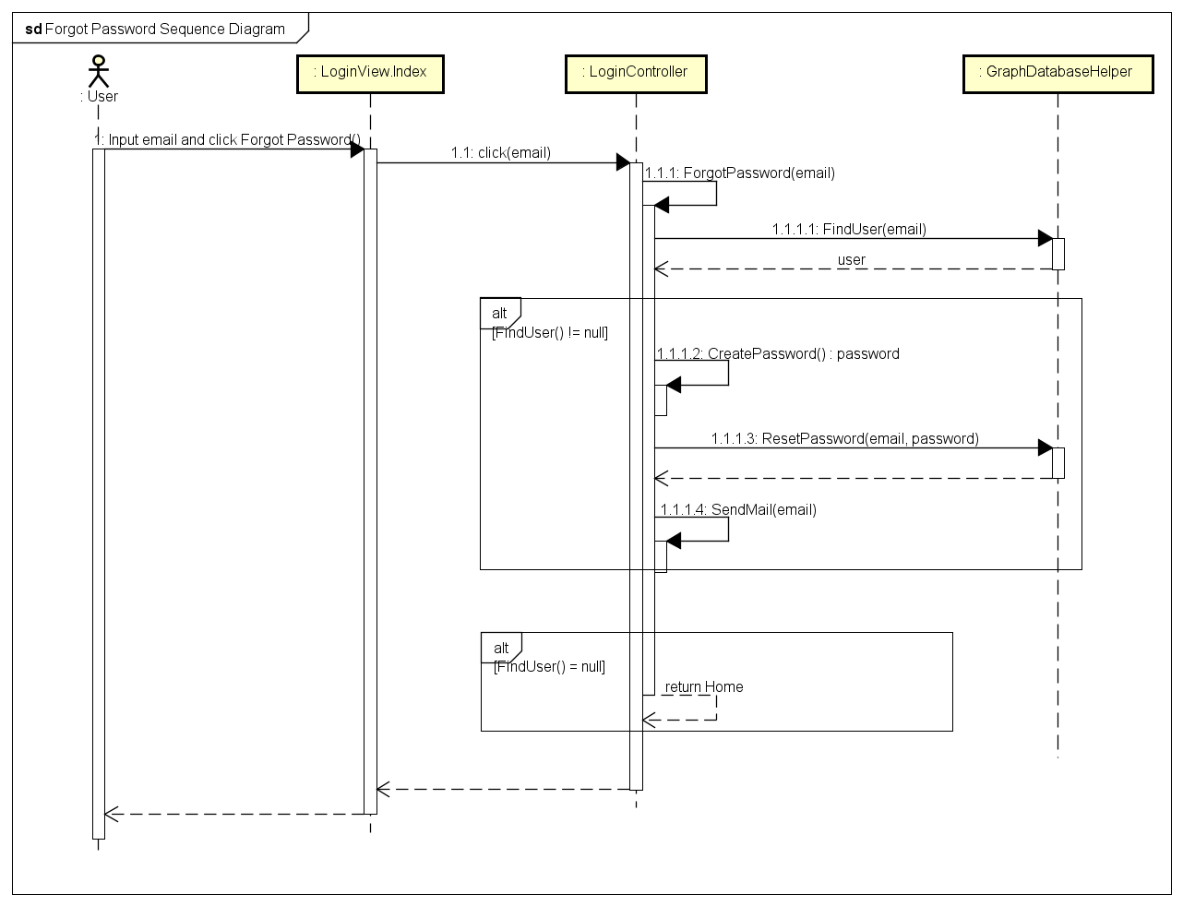

Figure 53: Forgot Password sequence diagram